The Lowell Sun

UPDATED: 11/01/2015

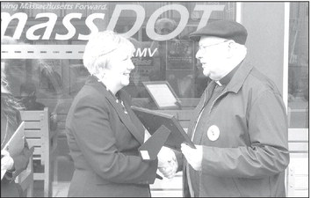
State Sen. Eileen Donoghue received an award from the Merrimack Valley Project and its leader, the Rev. Paul Ouellette, for her work in getting Burmese added to languages available for drivers permit tests at the Registry of Motor Vehicles. At a press conference, Ngay Meh said: As soon as I got the learner s permit, I went to driving school. I finished my lessons and I have a road test this Sunday morning. Please pray for me. (Good luck!)

