Jewish groups lament immigration crisis during protest at Boston office
By Abigail Feldman and Jeremy C. Fox Globe Correspondents, Updated August 11, 2019, 8:26 p.m.
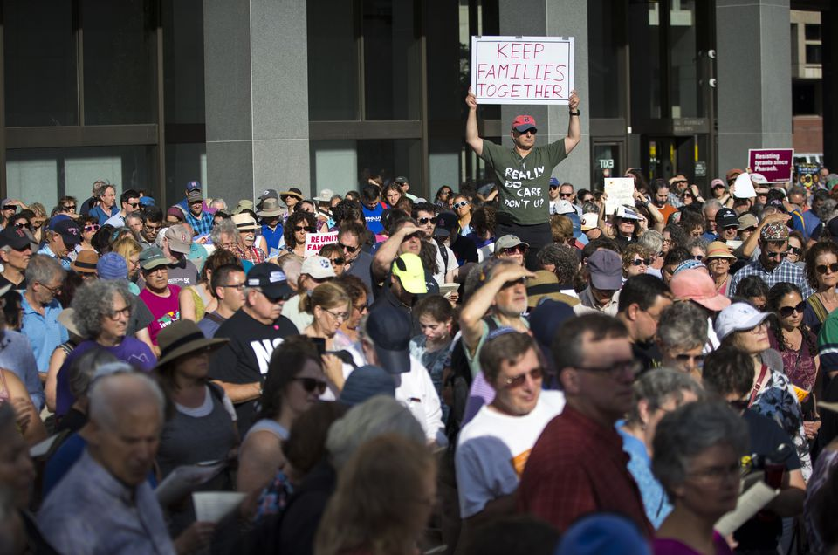
People gathered Sunday for the protest outside the John F. Kennedy Federal Building in Boston. (NIC ANTAYA FOR THE BOSTON GLOBE)

Hundreds of people, young and old, gathered to sing laments of Tisha B’av outside the John F. Kennedy Federal Building in downtown Boston late Sunday afternoon, shifting the focus of the traditional day of mourning from ancient struggles to an issue dominating today’s headlines.

The holiday, known as the saddest of the Jewish calendar, is typically observed as a commemoration of the destruction of the Temple of Jerusalem and persecution of the Jewish people. But Sunday’s crowd gathered to mourn what they described as a current tragedy — the separation of immigrant children from their families at the southern border and living conditions inside immigrant detention centers.

About 10 leaders from Jewish organizations around Greater Boston led the crowd in songs from the Book of Lamentations. Many held signs above their heads with messages such as, “Close the camps,” and, “Keep families together,” during the ceremony.

The rally, organized in part by an alliance of rabbis known as T’ruah, along with several others was meant to highlight the “calamity against communities” posed by the nation’s current immigration practices, said Michael Rothbaum, a rabbi from Acton.
Sign Up
“It is our national catastrophe,” Claudia Kreiman, a rabbi from Brookline added. “We cannot separate our experience of being broken and persecuted from what is happening now.”

Between songs, the leaders read testimonies from children at the border, including a 12-year-old whose mother and father live in Massachusetts.

“Every night my sisters keep asking me, ‘When will our mommy come get us?’ I don’t know what to tell them.”

Some in the crowd, like Georgia Leonce of Lynn, knows firsthand the consequences of the nation’s current immigration policies. Her husband was deported to St. Lucia more than a year and a half ago, and she cares for her two young sons alone. One of them now suffers from panic attacks, she said.

“It breaks my heart every day because we did everything right,” Leonce said with tears in her eyes.

Her husband worked three jobs, she said, and never took food stamps to feed the family.

“My husband didn’t deserve it,” she said.

In the middle of the rally, leaders asked the crowd to face the JFK Federal Building, which houses the Citizenship and Immigration Services, and shout their thoughts.

“Where’s your humanity?” a woman could be heard yelling.

“How long, oh, Lord?” said another.

Barbara Penzner,62, a rabbi in West Roxbury, said she recently went to Guatemala, where she was struck by how American policies had played a part in creating social unrest there.

“It just broke our hearts,” she said. “I feel a tremendous responsibility to help these people have a better life.”

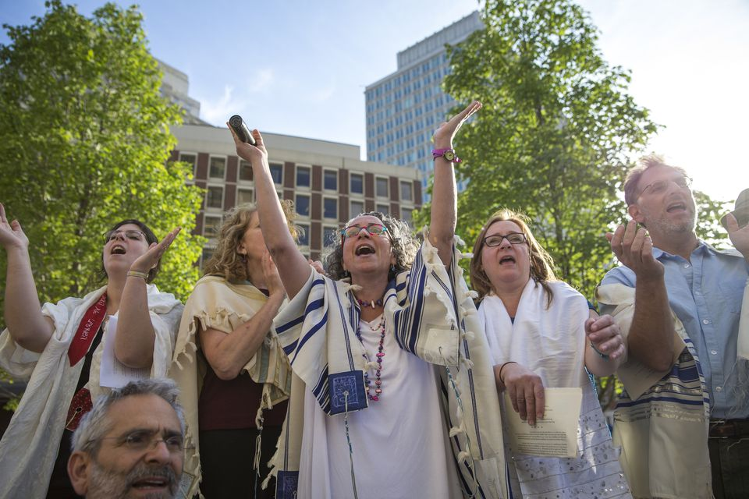
Clockwise, from upper left: Cantor Vera Broekhuysen of Haverhill, Barbara Penzner of West Roxbury, Claudia Kreiman of
Brookline, Robin Sparr of Lowell, and Andrew Vogel of Brookline sang in prayer. (NIC ANTAYA FOR THE BOSTON GLOBE)
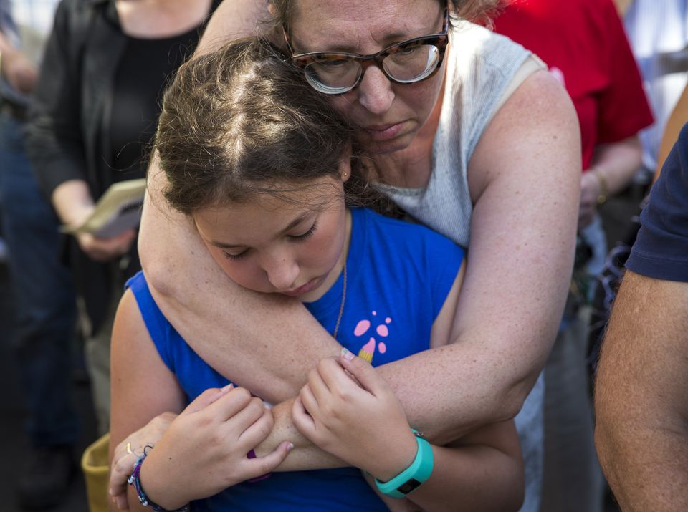
Mara Benjamin of Northampton held her daughter, Shifra Kabakov, 10. (NIC ANTAYA FOR THE BOSTON GLOBE)

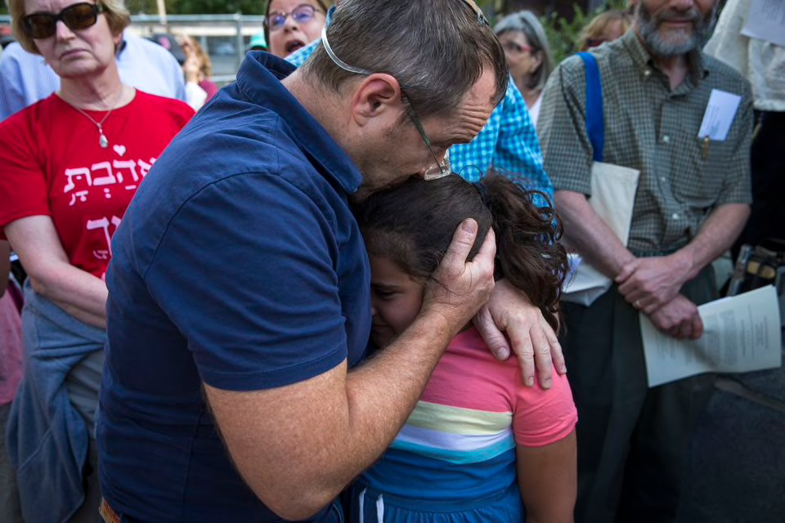
Steven Goldstein of Brookline embraced his daughter, Amalia, 8. (NIC ANTAYA FOR THE BOSTON GLOBE)

Abigail Feldman can be reached at abigail.feldman@globe.com. Jeremy C. Fox can be reached at jeremy.fox@globe.com. Follow him on Twitter @jeremycfox.

