Parker Foundation awarded $1.2 million to Lowell nonprofits in 2021
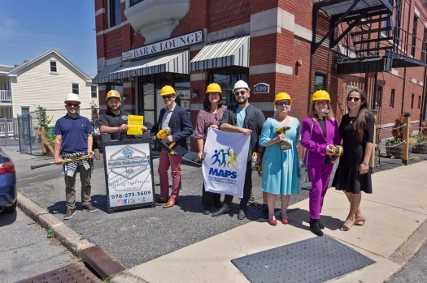

June 14, 2021 – The Massachusetts Alliance of Portuguese Speakers is renovating the organization’s building on Central Street in Lowell to include six new private offices, a reception area, conference room, kitchen, and restrooms on the first floor of the building and partially renovating the second floor. The work will also include the installation of a new wheelchair lift, which was made possible by a generous grant from the Parker Foundation. Photos courtesy the Massachusetts Alliance of Portuguese Speakers

By TREA LAVERY | tlavery@lowellsun.com |PUBLISHED: February 26, 2022 at 4:10 p.m.

LOWELL — The Theodore Edson Parker Foundation awarded nearly $1.2 million to nonprofit organizations that work in the city in 2021, with another $530,000 to come this year.
Community Teamwork Inc. received the most funding in 2021, including a $100,000 grant to offer fuel and heating assistance and to address food and housing insecurity, as well as a $50,000 grant to create a new position in the organization’s subsidiary Common Ground Development Corp. to facilitate succession planning and new affordable housing.
Other top recipients in 2021, each receiving $100,000, were Acre Family Child Care to purchase a new building; the Boys & Girls Club of Greater Lowell for its “Believe & Become” campaign to upgrade and expand its facility; and Project Learn to help the city’s public schools recruit more teachers that reflect the student body’s diversity.
“We are very grateful to the Theodore Edson Parker Foundation for making a multiyear commitment to Believe & Become, our current $18 million Comprehensive Capital Campaign,” said Boys & Girls Club of Greater Lowell Executive Director Joe Hungler. “This project is transforming Boys & Girls Club of Greater Lowell’s outdated 49-year-old facility into a modern youth center and increasing its staffing to support up to 600 young people, ages 8 to 18, each day, double the Boys & Girls Club’s current capacity.”
Hungler said the project will be completed in 2023 and will include a new teen center, larger career and college readiness center, expanded STEM (science, technology, engineering and math) and education spaces, a new cafe and community center and the only youth theater in Lowell.
The Parker Foundation was created in 1944 to benefit charitable, educational and philanthropic organizations in the area to carry on the legacy of Parker, an inventor and physician. It is managed by trustees Karen Carpenter, David Donahue, Sophy Theam and Luis Pedroso.
The foundation’s former president, Newell Flather, died at 83 in August after 40 years of service as chair.
Grant recipients are divided into human services, community and economic development, education, health and arts and culture. Human services grants made up 64% of the foundation’s giving in 2021, with a total of $736,000. Capital grants totaled $403,500.
In addition, the foundation’s Equity and Inclusion Initiative, now in its fifth year, gives grants to organizations led by people of color or that benefit immigrant and refugee communities and communities of color.
More than 30% of the grant portfolio went to these organizations, including $75,000 in startup support for Fortaleza, a new Latinx education advocacy group; $50,000 for the International Institute of New England to cover resettlement costs to at least 200 Afghan evacuees in Lowell; $50,000 each to the Center for Hope and Healing and the Massachusetts Alliance of Portuguese Speakers to renovate their new buildings; and $30,000 for voter education efforts related to the city’s new district-based municipal voting system to a coalition of organizations that included Lowell Votes, Coalition for a Better Acre, Cambodian Mutual Assistance Association, Latinx Community Center for Empowerment, the Merrimack Valley Project, the Lowell Alliance and the Lawyers’ Committee for Civil Rights.
For more information on the foundation and a full list of grant recipients, visit parkerfoundationlowell.org.

