My Work on This Year’s Budget ~ IN YOUR CORNER with SENATOR DIANA DIZOGLIO

June, 2019

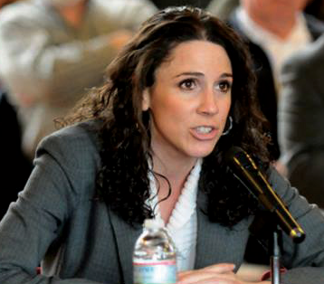
Hello Valley Patriot Readers,

After a spirited week of debate, the Massachusetts State Senate has delivered a state budget for the 2020 Fiscal Year.

The budget will now go to Conference Committee, where members of the House and Senate will collaborate on combining their respective proposals into a final budget by the start of the new fiscal year in July.

During the Senate’s budget week, I successfully advocated for the inclusion of several amendments I filed, some for organizations and programs specifically in the Merrimack Valley and others that will have a positive impact on residents across the Commonwealth.

Among the amendments I’m most proud of is one adopted into the Senate Budget for additional resources toward improvements at the Vietnam Veterans Memorial at Mill Brook Park in Haverhill. These funds will assist with renovations currently underway at the park, including hydroseeding and the installation of an ADA-compliant crosswalk.
In total, the City of Haverhill lost 13 men during the Vietnam War. It is because of Haverhill’s ties to the war and the respect with which its citizens hold our military servicemen and women that I so strongly believed funding needed to be set aside in the budget for this important project.

Another two amendments I filed to the Senate Budget pertain to my proposed Merrimack River District Commission – one to create it and another to fund it. This commission will bring together stakeholders from all along the Merrimack River, who live here and care deeply about the river’s health, to address issues around pollution, including discharge from combined sewer overflows (CSOs).

The commission will include representatives from state agencies and environmental groups and will advise the legislature and work to develop a plan to clean and maintain the river moving forward.

Earlier this year, I was pleased that we were able to receive funding from last year’s Environmental Bond Bill for the purchase of an emergency generator at the Greater Lawrence Sanitary District’s pumping station in North Andover.
Those resources were secured so our communities would not have to endure a situation where raw, untreated sewage slipped into the Merrimack as the result of a long-term power outage. I believe the forming of this commission is just as important as the generator, for it will create a master plan to prevent and mitigate future accidents and hazards that could harm our river.

Another amendment I was able to secure included funding toward a pilot program to notify swimmers and boaters of CSOs in the Merrimack.

With cities like Haverhill, Lawrence and Methuen all sitting atop aging sewer systems, CSOs are a great concern here in the valley. So while the legislature works with local mayors to advance sewer infrastructure improvements, this program will use flagging and mobile app alerts to notify people using the river of potential CSOs.

On a different note, I was so pleased to see adopted into the budget an amendment I filed to fund another pilot program, one to provide a 24/7 transportation service for people in the Merrimack Valley looking to get a ride to a rehabilitation or detox center.
For people struggling with addiction, one of the greatest impediments to obtaining treatment is often a lack of transportation to a facility with an available bed. Leaders at the Merrimack Valley Project, a group of faith, labor and community leaders, which worked with me on the amendment, estimate they receive as many as 30 requests a month for rides to rehab and detox facilities from people in Lawrence and Lowell alone.
This funding will provide tremendous support for groups like the Merrimack Valley Project and help more people obtain the treatment they need to get new leases on life.
As always, I welcome any and all correspondence regarding bills and legislation I am working on. If you wish to contact me, please send an e-mail to Diana.DiZoglio@masenate.gov or call my office at (617) 722-1604 anytime.
Yours in service, Diana ◊

